**Welcome To The North Lincoln**

**Band of Knights!**

The North Lincoln Band has a strong tradition as an excellent band that combines outstanding musicianship and pageantry to produce exciting performances. We mix hard work, determination, and fun to build memories that will last a lifetime. Band is an academic class at North Lincoln High School. 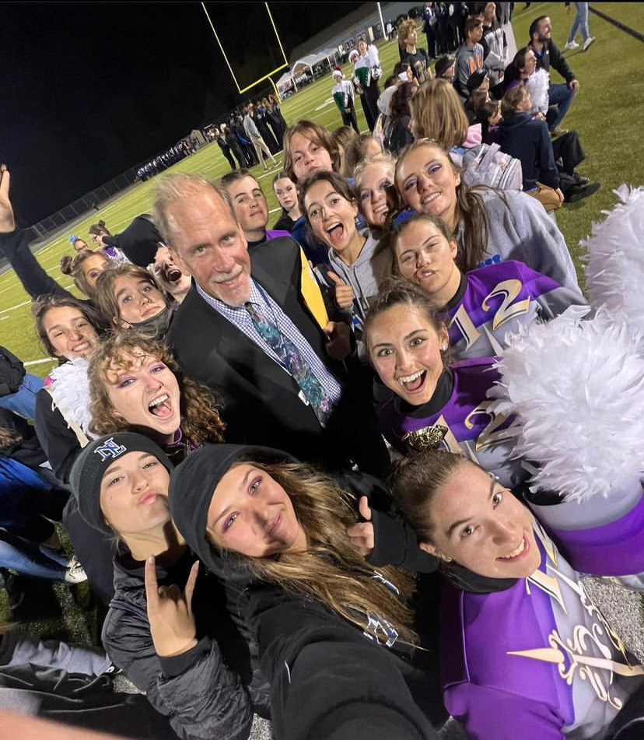

Students receive academic credit and have the opportunity to earn weighted grades in certain ensembles. Band does require rehearsals and performances outside the regular school year.

Being a part of the North Lincoln Band means you will be a part of one of the most outstanding band programs in North Carolina. As a beginning high school student you will start your high school experience knowing over 100 other students before the first day of school! This is a guide book to help new band members and their families begin this journey with the North Lincoln Band. It should make the first few days in band a little easier in terms of language, what to expect, and how to prepare.

**The North Lincoln Band Provides Many Opportunities**

* Marching band, includes Musicians and Color Guard
* Concert Band
* Symphonic Band
* Jazz Ensemble
* Winter Guard
* Winter Winds
* Percussion Ensemble
* Honors Bands; All-County, All-District, and All-State Honors Band

**Band Classes at North Lincoln High School**

Band is an important and diverse part of the curriculum at North Lincoln High School. Band students register for and enroll in the following band classes: Fall- Concert band for younger members, and Symphonic Honors Band for older. Fall concert band focuses on basic musicianship skills as well as preparing for a holiday concert. Both bands focus on musicianship skills, and prepare a holiday concert. The spring symphonic band and concert band continue to foster basic musicianship skills and prepare music for concert band festivals, a spring concert, and usually a pops concert. Members of the **Color Guard** who do not play a band instrument register for the **Music Specialization Class** class in the fall and take other electives in the spring. Concert band and marching band are open to anyone willing to put forth the effort required. WInd Ensemble is by audition. We encourage all members to take band both semesters. There is more about scheduling later in this packet.

| **Band Courses at North Lincoln High School**  **Fall:** Beginning Band  Band Intermediate Honors  Music Specialization (guard class)    **Spring:**  Band Intermediate  Wind Ensemble Honors    **Please check out the sample schedule later**  **in this packet for an example of how band**  **can fit in your schedule.** |
| --- |

**The Marching Band at North Lincoln “Band of Knights”** Marching Band general information;

* Marching Band is an extracurricular activity
* Marching Band is not required to be in the band program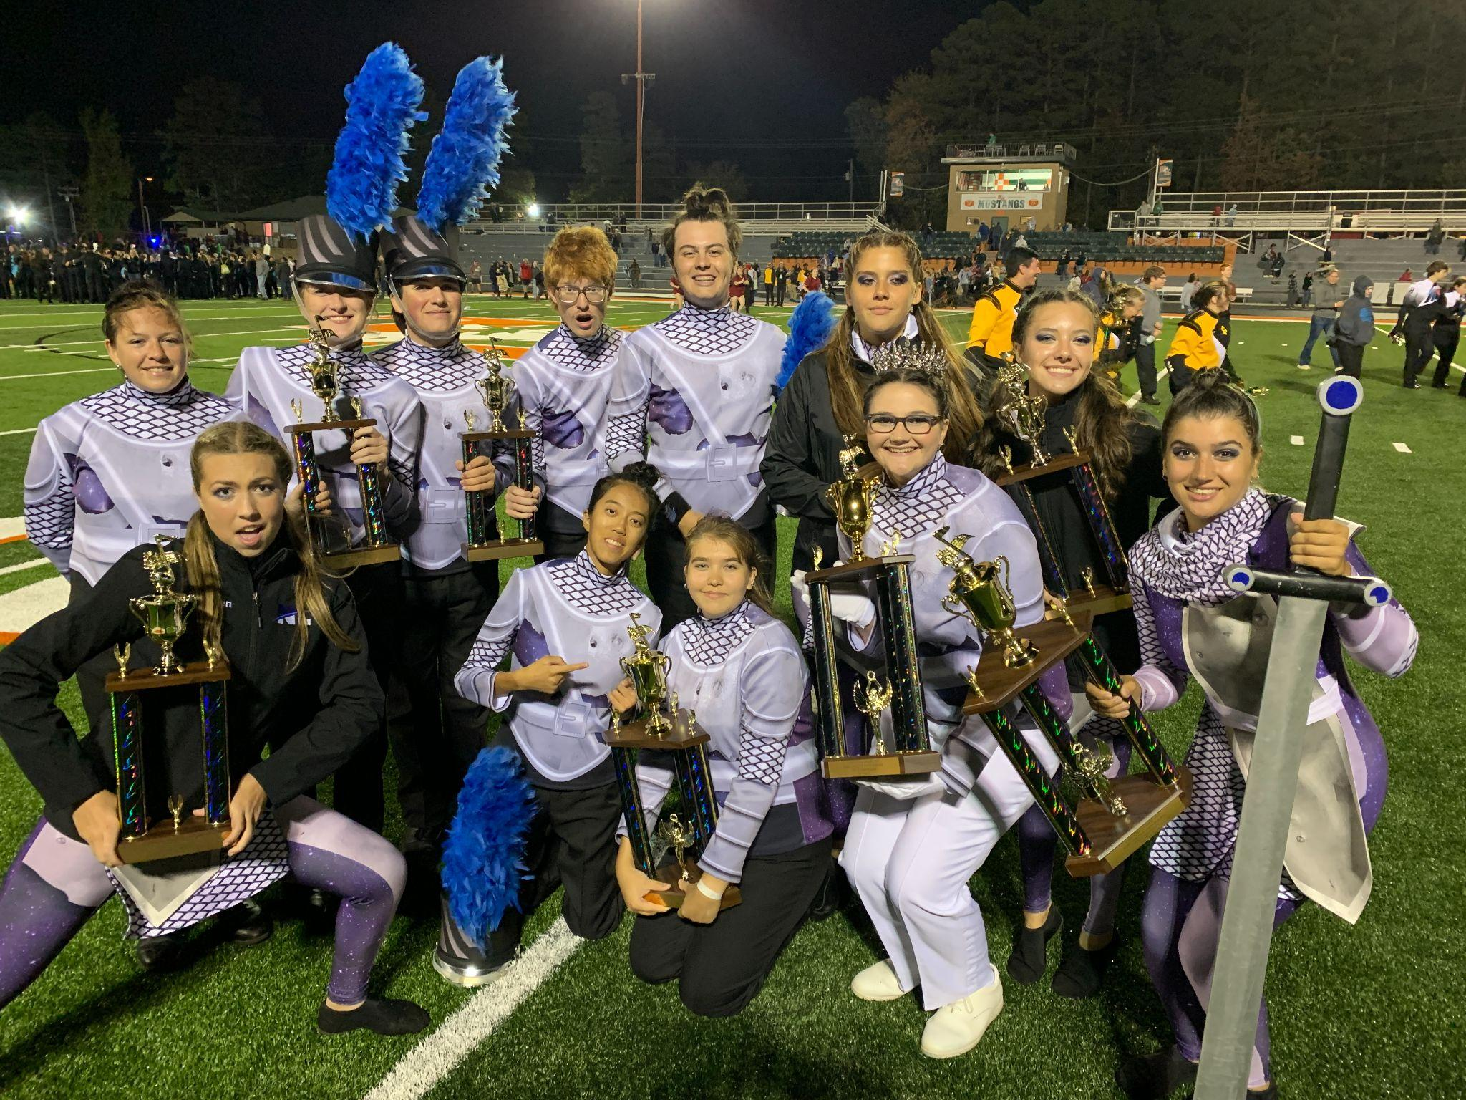
* The Band of Knights is the most visible part of the overall band program
* Band Camp is only for people doing marching band
* We highly encourage all band members to try marching band
* The group performs at all home football games plus competitions

The best way to describe marching band is to compare it to sports. Marching band is your fall sport. We practice after school 3 days a week. Our competitive season starts at the end of September and goes through October. The group has been highly successful over the years and many students find it to be their favorite part of high school.

**Summer Rehearsals and Band Camp**

Your Band journey begins with either a color guard mini-camp or spring practice. Spring practice is for new instrumental band members and is designed to be an introduction of our marching style, color guard fundamentals and life in high school band. It is a chance for new members to meet current members and make some friends so that band camp won’t be such an unknown. **Spring practice** is the time in the spring when the marching band meets for the first time. New members are taught the basics of marching and warm-ups the band uses on a regular basis. It is a time when those nervous or unsure about marching band get the opportunity to see what it’s like before fully committing to it. All interested members should try to attend. **Rookie Camp** is two rehearsals focused on teaching new members fundamentals that will help them be prepared for band camp. This will be June 6th and 7th from 8:30 am to Noon. **Summer rehearsals** for the entire band are held once weekly leading up to band camp. These rehearsals are required with the understanding that people will be out of town on vacations. The rule is; come if you are in town. If you’re out of town on vacation please just let me know for planning purposes. These rehearsals are fun and exciting for the members because they learn what the show music and design is all about. Band Camp and all other rehearsals are held at North Lincoln HS.

| **2024 Marching Band Important Dates**  April 30th, May 1, 2nd, 3:30 -5:30 @ NLHS **Spring Practice-** Including new members  May 28-29 th 8:30 am-noon **Rookie Camp…**all new members  June 19 July 11, 18  **Summer rehearsal** 6-8:30 pm (if you are in town)  July 22 through August 2nd **BAND CAMP** at North Lincoln High School  **Post band camp rehearsals;**  August 6th, 8th, 12th 6pm-8:30pm  **First Football Game August 23rd** |
| --- |

Typical **Band Camp** days involve marching rehearsals in the relative cool of the mornings and musical rehearsals indoors in the heat of the afternoon and then more marching or learning drill in the evening. The day always begins with the full band stretching together and then sections divide up and go with highly qualified instructors. Parents are encouraged to volunteer to help out at band camp. Parents are needed to offer support, cold clothes, water and ice and whatever is necessary to help the kids be successful. **Band camp is required for participation in marching band.**

Typically, at the end of band camp each year the band does a presentation of what they have learned at band camp for parents, families, and friends. This happens on the last Friday night of band camp.

**Concert Season**

The band’s annually hold a holiday concert sometime in December featuring concert music and some fun holiday favorites. During the winter, bands prepare for our annual NCBA district MPA which stands for Music Performance Assessment It depends on the instrumentation and make-up of each group as to whether or not they will participate in MPA each year. This decision is made by the director. Bands at MPA perform for three adjudicators and sight read for a rating. Ratings range from superior to excellent and on down. Band parents help provide chaperones for these events. The performances are free and open to the public. The bands usually give two other concerts in the spring. A spring concert and a pop’s concert made up of usually less serious works.

**Band Fees and Fundraising**

The band **assessment** is set each year by the band booster board and the director as a part of our budget process. These band fees are only for marching band. Fees are $350 with an additional travel fee of approximately $350 depending on what the band is doing each year, what contests we are going to, and/ or where we are traveling. This fee is only for marching band. In the spring, students will have the opportunity to register for marching band and will pay a $100 deposit securing their spot in the group. This is important. Once you register you will be written into the marching production that we produce over the summer. There are some rental fees for students who use school owned instruments. These fees help cover the cost of maintaining the instruments over the years.

It is important to note that **no student** will ever be denied participation in the band for financial reasons.

**Scheduling for band**

With most school systems adopting the 4x4 block scheduling system it became more difficult to schedule band for students all year long. As you can imagine, it's sometimes hard to get better at your instrument if you don’t play it throughout the year. Everytime you make improvements in your playing you have to re-learn them again if you don’t play for quite some time. We ask that band members try to take band each semester. Approximately 85% of band students take both semesters. Every student is different. Some students struggle to keep band in their schedule as much as they would like while others have band and free periods to spare. Most of our students are college bound. Band looks good as an academic credit as well as an extracurricular activity on your college resume. You can receive honors credit for band which in most cases can help your GPA.

We have attached a sample schedule of a recent graduate who is now attending North Carolina State University. This is just a sample; Your schedule could include other classes, Gaston College Classes, electives, AP classes,etc. This student enjoyed band, was academically driven, successfully did both, and is now in a very prestigious college of his choice.

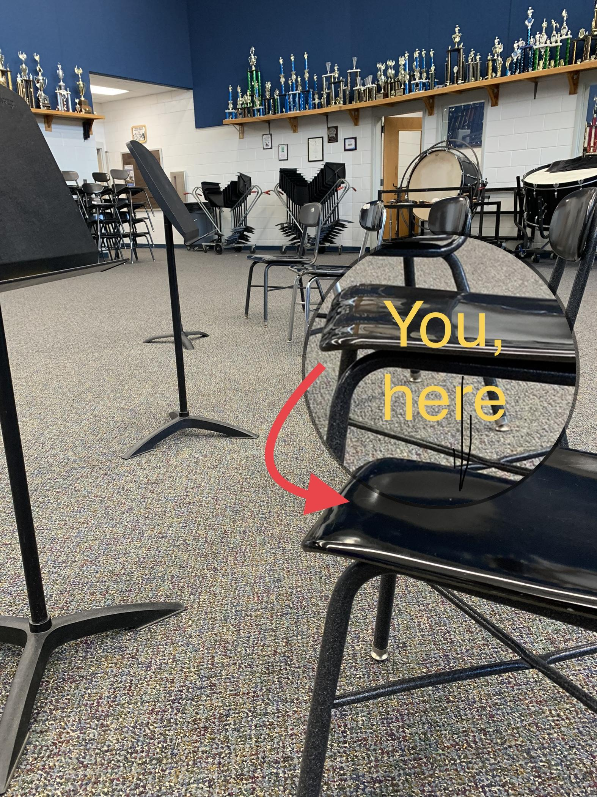

**Band Vocabulary**

**Assessment** is the term used to describe the band fees associated with the marching band. It is determined as a part of the Band Booster Club budget each year.

**Band Banquet and Awards** are held every spring to honor all band members for their accomplishments during the school year. This is a final farewell to our graduating seniors and the end of the year video is presented.

**Band Office phone** is 704-736-1969 ext. 61716

**Band’s of America** (BOA) is a private organization that provides opportunities for performance, learning and excellence through music education. It holds regional events each year for marching bands and Grand Nationals each year in Indianapolis Indiana. They also sponsor a very fine summer music camp called the Summer Symposium for high school students. See more at [www.bands.org](http://www.bands.org).

**Blue Box** is for payments and correspondence to the treasurer and is hung right outside of Mr. Minick’s office. Money for almost anything can be turned in there. Please put in a small envelope and label who it is from and what it is for. Checks that should be made out to North Lincoln Band Boosters.

**Color Guard** is an ensemble of students utilizing flags, rifles, sabers and other equipment to provide visual enhancement of the music played by the musicians. Students audition annually to be a part of the group. Guard members are considered a part of the marching band. See also Winter Guard.

**District Band** students can audition for all-district band sponsored by the South Central District Bandmasters Association. Placing high enough in this ensemble can lead to eligibility to audition for NC Honors Band.

**Drum Major** is the student leader chosen by audition to conduct the band and serve as its highest ranking student leader.

**Honors Band** is sponsored by the North Carolina Bandmasters Association. Students are eligible to audition based on district band placement. See www.ncbandmasters.org.

**Marching Band**. Students in the NLHS band program do not have to participate in marching band. Nonetheless, the marching band attracts the vast majority of band students. The marching band is composed of the **musicians** and the **color guard**. It brings excitement to the football field in a treat for the senses combining music with other performing arts. This group performs at football games and competitions. The **Pit** consists of those musicians that play the stationary instruments in front of the field and do not march during the performances.

**Pit Crew** is a group of dedicated parents who transport the Pit instruments and props to and from each performance as well as on and off the field. The pit crew also transports the larger instruments to concerts.

**Round Table** is how we refer to our annual band competition and parade held at North Lincoln High School near the beginning of the fall season. It is an annual community event as well as our largest fundraiser. All band family members are needed to help run this historic event.

**Rookie Camp** is a two day event for all new members on June 7th and 8th from 8:30 am until noon. Members learn marching basics and musical exercises. They get individual attention from staff members in addition to the chance to get to know fellow band members.

**Spring Practice** is a practice held in the spring for returning members and new members. The dates are highly encouraged. We teach a few basics of playing and marching and give new members a chance to see what things are like so they are not so intimidated.

**Show Shirt or Band Tee Shirt**. The NL Band Boosters provides each band member with a show shirt designed based on the theme of the competition show. Show shirts are worn to show pride in the band and as a casual uniform as necessary. Family members and students can purchase additional shirts at reasonable prices. These are great for competitions!

**Summer Uniform**. These are uniforms used by the marching band members for more casual performances held earlier in the marching band season. Each student will wear the Band Tee Shirt they have been issued, black knee-length shorts, (not gym shorts) and mostly white tennis-shoes. The shorts and shoes will not be provided by the band boosters. These uniforms allow the band to perform in hot weather yet still have the classy uniform look we are accustomed to.

**The Show** You will hear students and parents refer to “The Show.” The show is the production that the marching band does each year. Each year is different. The show is performed at football games as well as our competitions. The show evolves; what you see first will be just the beginning of it and gradually through the season we will finish and refine it. Sometimes there may even be major changes to it. The show reveal is a big deal to returning members because they know we will be living with the music and visual ideas for several months.

**Uniforms**. Each band member will be assigned a uniform that will need to be altered to fit them. Uniforms are cleaned at home and returned to the school where they remain until the next use. Each student is responsible for returning each part of their uniform to the garment bag and placing the bag on the garment racks. The uniform includes accessories, gloves, gauntlets, shoes and socks. Band hats and plumes are kept in separate boxes.

**Winter Drumline** is a program like that of the guard that allows percussionists to perform throughout the winter. They perform at shows on the local regional and national level indoors on gym floors similar to that of the winter guard. Students are not required to participate although there are members that play other instruments that perform with the winter drumline as well. Additional fees do apply for participation.

**Winter Guard**. This is a post-marching-season activity for color guard members held during the winter/spring semesters, December-April. The winter guard competes against other color guards on a state, regional, and international level. The guard learns a new show routine that is performed to an artist’s recorded music instead of the band. They perform on a tarp in gymnasiums. Color guard members are not required to participate in Winter Guard. Anyone is eligible to join, even if they did not participate in Color Guard during marching band season. This is an excellent opportunity for guard members to strengthen their dance movement and equipment skills. There are additional fees assessed and other fundraising for participation in the Winter Guard season. *See also Color Guard*.

**Winter Winds.** This is a new program that started just this year. The easiest way to explain winter winds is marching band on a smaller scale done inside a gym. It’s a fun activity where select performers hone their skills both musical and visual, learn a new show, and compete across the state and region.

**Winter Programs** include the winter guard, winter winds and winter drumline. These are programs that allow students to excel in their particular discipline and therefore benefit the band program as a whole.

